# Appendix F: Part 2: Attachment 1

**Climate Change Projections Development**

Climate Change Projections Development

The purpose of this attachment is to detail the steps in developing climate change boundary conditions for the CalSim II model. Figure 1 shows the dataset development and modeling sequence.

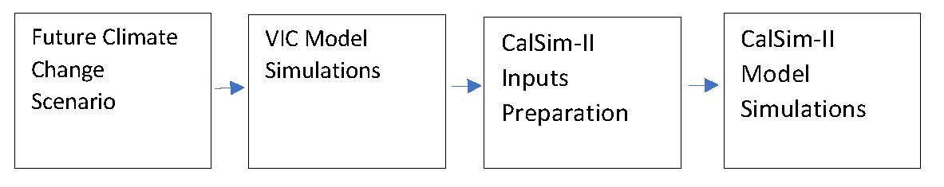

Figure 1 Dataset Development and Modeling Sequence

## Historical Observed Meteorological Data

Livneh et al. (2013) daily historical meteorology data at 1/16th degree (~6 km) (~3.75 miles) spatial resolution over the period 1915 through 2011 was used to develop historical VIC simulation and future climate change scenarios based on quantile mapping approach. These historical data were adjusted based on PRISM data (Daly et al., 1994) to correct biases found in the pre-1950 period. These datasets have already been reviewed under the Sacramento – San Joaquin River Basins Study, Central Valley Flood Protection Plan (CVFPP) 2017 Update, and Water Storage Investment Program (WSIP).

## Future Climate Change Scenario

The climate change scenario centered around 2035 (2020-2049) was developed with the ensemble informed climate change scenarios method, using the 20 Coupled Model Intercomparison Project 5 (CMIP5) global climate model projections. These projections were downscaled using the localized constructed analog (LOCA) method at 1/16th degree (approximately 6 kilometers [km], or approximately 3.75 miles) spatial resolution (Pierce et al., 2014). The LOCA method is a statistical scheme that uses future climate projections combined with historical analog events to produce daily downscaled precipitation, and maximum and minimum temperature time series data. Further details on the LOCA downscaling can be found in WSIP Technical Reference Document Appendix A (CWC, 2017).

The 20 CMIP5 global climate projections were selected by the California Department of Water Resources (DWR) Climate Change Technical Advisory Group (CCTAG) as the most appropriate projections for California water resources evaluation and planning (DWR CCTAG, 2015) (Table 1). The climate model projections were generated with two emission scenarios, one optimistic (Representative Concentration Pathway [RCP] 4.5) and one pessimistic (RCP 8.5), identified by the IPCC for the Fifth Assessment Report (AR5) (IPCC, 2013).

Table 1. CCTAG Recommended Climate Models

| Model Number | Model Name | Model Institution | Model Resolutiona |
| --- | --- | --- | --- |
| 1 | ACCESS-1.0 | Commonwealth Scientific and Industrial Research Organization and Bureau of Meteorology | 192 x 145 (165 km) |
| 2 | CCSM4 | National Center for Atmospheric Research | 288 x 192 (110 km) |
| 3 | CESM1-BGC | National Science Foundation, Department of Energy, National Center for Atmospheric Research | 288 x 192 (110 km) |
| 4 | CMCC-CMS | Centro Euro-Mediterraneo per I Cambiamenti Climatici | 192 x 96 (165 km) |
| 5 | CNRM-CM5 | Centre National de Recherches Météorologiques, Centre Européen de Recherche et Formation Avancées en Calcul Scientifique | 256 x 128 (123 km) |
| 6 | CanESM2 | Canadian Centre for Climate Modeling and Analysis | 128 x 64 (247 km) |
| 7 | GFDL-CM3 | Geophysical Fluid Dynamics Laboratory | 144 x 90 (219km) |
| 8 | HadGEM2-CC | Met Office Hadley Centre | 192 x 145 (165 km) |
| 9 | HadGEM2-ES | Met Office Hadley Centre; additional HadGEM2-ES realizations contributed by lnstituto Nacional de Pesquisas Espaciais | 192 x 145 (165 km) |
| 10 | MIROC5 | Atmosphere and Ocean Research Institute at the University of Tokyo, National Institute for Environmental Studies, and Japan Agency for Marine-Earth Science and Technology | 256 x 128 (123km) |

Notes:

km = kilometers

Models are listed alphabetically.

aSize of the model's atmospheric grid (number of longitudes by number of latitudes)

Consistent with the Bay-Delta Conservation Plan/California WaterFix Analyses (ICF, 2016), historical temperature and precipitation were adjusted to represent future conditions with the quantile mapping approach. Adjustments to temperature and precipitation were calculated with cumulative distribution functions mapped with the 20 downscaled global climate model projections from the Coupled Model Intercomparison Project Phase 5 (CMIP5) (Taylor et al., 2012).

The quantile mapping approach involves the following steps:

* Extract a 30-year slice of climate model data (precipitation, and maximum and minimum temperatures) from downscaled ensemble climate projection centered on reference (1995: 1980-2009) and future periods (2035: 2020-2049).
* For each calendar month (e.g. January) of the future period, calculate cumulative distribution function (CDF) of temperature and precipitation at each grid cell.
* For each calendar month of the model simulated reference period (1980-2009), calculate CDFs of temperature and precipitation at each grid cell.
* Calculate the ratio (future period divided by reference period) for precipitation and ‘deltas’ (future period minus reference period) for each quantile from the reference and future period CDFs.
* Apply these ratios and deltas to develop a monthly time series of temperature and precipitation at 1/16th degree (~6 km) (~3.75 miles) over the period 1915 -2011 that incorporates the climate shift of the future period.

Convert monthly time series to a daily time series by scaling monthly values to daily sequence found in the observed record.

Figure 2 shows the projected change in long-term average temperature for the major watersheds in the Sacramento and San Joaquin River Basins using the climate change scenario for 2035 future conditions. Compared to the reference period (1995), average temperature is projected to increase by at least 1.5°C in all major watersheds. The highest temperature increases in the Sacramento River Basin occur in the Yuba River (1.6°C) and Feather River (1.7°C) watersheds. All major San Joaquin River Basin watersheds are expected to increase by 1.6°C.

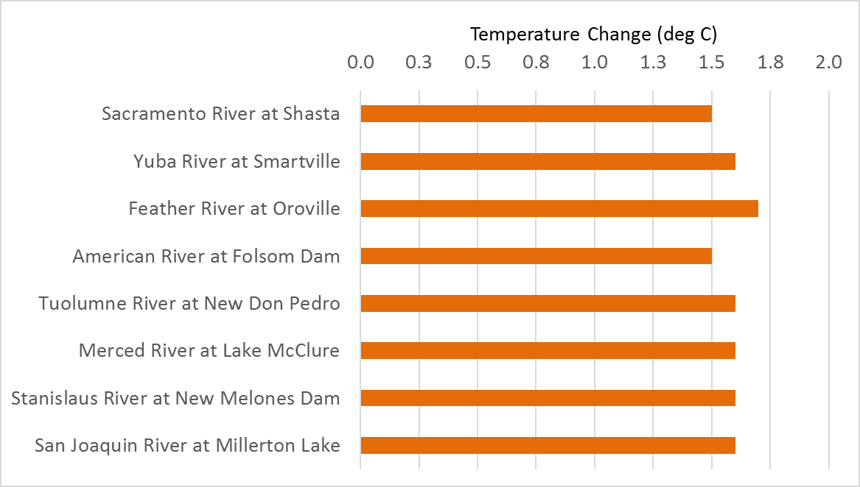

Figure 2. Projected Change in Average Temperature for Major Watersheds in the Sacramento and San Joaquin River Basins

Projected change in long-term average precipitation for major watersheds in the Sacramento and San Joaquin River Basins are presented in Figure 3. Overall, all major watersheds are projected to be wetter, with average precipitation increases of 2.4% to 4.4%. Sacramento River Basin is projected to experience a higher increase in long-term average precipitation than the San Joaquin River Basin.

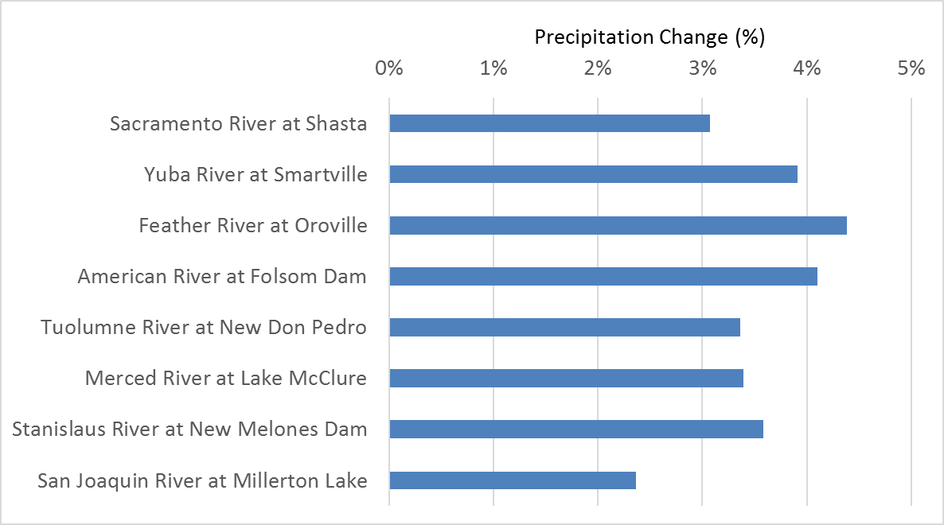

Figure 3. Projected Change in Precipitation for Major Watersheds in the Sacramento and San Joaquin River Basins

Projected streamflow data were generated by inputting adjusted temperature and precipitation time series data for 2035 conditions into the Variable Infiltration Capacity (VIC) hydrologic model.

## VIC Model Simulations

Historical and projected surface runoff and baseflow at 1/16th degree (approximately 6 km, or 3.75 miles) were generated by inputting historical and projected meteorological data into the VIC model. The VIC Model (Liang et al., 1994, 1996; Nijssen et al., 1997) simulates land-surface-atmosphere exchanges of moisture and energy at each model grid cell. The VIC Model incorporates spatially distributed parameters describing topography, soils, land use, and vegetation classes.

VIC simulated surface runoff and baseflow were used to produce routed streamflows at several locations in the Sacramento and San Joaquin River Basin. VIC model and routing model network are consistent with modeling conducted in the WSIP. Further details on the VIC model and routing model can be found in WSIP Technical Reference Document Appendix A (CWC, 2017).

## Sea Level Rise Scenarios

For this analysis, the existing conditions and the Refined Alternative 2b were modeled using climate centered around year 2035 with 15 cm of SLR, and climate centered around year 2035 with 45 cm of SLR. The two considered SLR scenarios reflect the range of projected sea level values identified in the latest Ocean Protection Council Sea-Level Rise Guidance released in 2018 (OPC, 2018).

## CalSim-II Inputs Preparation

Climate and sea-level change are incorporated into CalSim-II in two ways: changes to the input hydrology, and changes to the flow-salinity relationship in the Delta due to SLR.

The following methods were used to calculate projected CalSim-II inflow data:

* For larger and smaller watersheds, simulated changes in streamflows (simulated future streamflows divided by historical simulated streamflows) were applied to the CalSim-II inflows. These fractional changes were first applied for every month of the 82-year period consistent with the VIC Model simulated patterns. A second order correction was then applied to confirm that the annual shifts in runoff at each location were consistent with that generated from the VIC Model. Similarly, fractional changes were also used to simulate change in precipitation and temperature as needed for calculation of certain parameters used in CalSim-II. This approach is consistent with the approach used in the BDCP/CA WaterFix modeling.
* For larger watersheds where streamflows are heavily impaired, a process was implemented by calculating historical impairment based on observed data and adding that impairment back onto the VIC Model simulated flows at a location upstream of the impairment. This approach is consistent with the approach used in the WSIP CalSim-II modeling under future conditions.
* Water year types and other indices used in system operation decisions by CalSim II were regenerated using adjusted flows, precipitation, or temperature as needed in their respective methods.
* SLR effects on the flow-salinity response in CalSim-II were incorporated by a separate Artificial Neural Network (ANN) for future climate condition.
* SLR effects were used in the regression equations to estimate the flow split between the Sacramento River and Georgiana Slough at times when the Delta Cross Channel (DCC) is open or closed.

## Use of Fractional Changes for Climate Data

Fractional changes in streamflows (simulated future streamflows divided by historical simulated streamflows) were applied to the CalSim-II inflows for larger and smaller watersheds. In addition, projected precipitation, used to calculate forecasts, were projected with fractional changes. Change in temperature, used to calculate Old and Middle River flow requirements, were projected with absolute changes. These are further described in the following subsections.

### Streamflows

For smaller and larger watersheds in the system, climate change ratios were used to adjust CalSim-II inflow data obtained from the 2017 SWP Delivery Capability Report (DWR, 2018). Tables 2 and 3 list these small and large watersheds, respectively. The climate change ratios were computed based on VIC Model simulations using historical, detrended climate forcing and climate change projections.

Table 2. River Locations for Upper Watersheds in CalSim-II

| River Locations | CalSim Arc | Approach |
| --- | --- | --- |
| Trinity River at Trinity Lake | I1 | Developed climate change ratio |
| Sacramento River at Shasta Dam | I4 | Developed climate change ratio |
| Feather River at Oroville | I6 | Developed climate change ratio |
| American River North Fork + Middle Fork | I300 | Developed climate change ratio. Partitioned from American River (I300 + I8) based on monthly ratios (I300/(I300+I8)) in CalSim-II inflow1 |
| American River South Fork + Local Flow | I8 | Developed climate change ratio. Partitioned from American River (I300 + I8) based on monthly ratios (I8/(I300+I8)) in CalSim-II inflow1 |
| Cosumnes River at Michigan Bar | I501 | Developed climate change ratio |
| Calaveras River at New Hogan | I92 | Developed climate change ratio |
| Merced River at Lake McClure | I20 | Developed climate change ratio |
| San Joaquin River at Millerton Lake | I18_SJR + I18_FG | Developed climate change ratio |
| San Joaquin River at Millerton Lake (without Fine Gold Creek) | I18_SJR | Developed climate change ratio. Partitioned from San Joaquin River inflow to Millerton Lake (I18) based on monthly ratios in CalSim-II inflow1 |

1CalSim-II inflow data were obtained from the DWR ITP baseline study.

### Precipitation

CalSim-II requires runoff forecasts for the Shasta, Feather, and American river basins. In practice, statistical forecast functions are developed based on observed precipitation and runoff. To mimic the same procedure for forecasts in future climate conditions, forecast functions were developed using projected precipitation and runoff. This approach is consistent with the WSIP CalSim-II modeling under future conditions.

The following steps were taken:

* Basin-wide average precipitation was computed for future climate condition.
* Sensitivity factors for precipitation were calculated in reference to historical data for future climate scenario.
* Historical precipitation indices were perturbed to obtain estimated precipitation indices under future climate scenario. Sensitivity factors for precipitation indices are calculated as the ratio of climate precipitation to historical precipitation for each basin.
* Perturbed precipitation index estimates were then used to develop regression equations for forecasted runoff.

Table 3. River Locations for Small Watershed Tributaries in CalSim-II

| Tributary | CalSim Arc | Approach |
| --- | --- | --- |
| Cow Creek | I10801 | Developed climate change ratio, and used as reference for other locations |
| Battle Creek | I10803 | Used climate change ratio developed based on Cow Creek |
| Cottonwood Creek | I10802 | Developed climate change ratio |
| Deer Creek | I11309 | Developed climate change ratio, and used as reference for other locations |
| Paynes Creek | I11001 | Used climate change ratio developed based on Deer Creek |
| Red Bank Creek | I112 | Used climate change ratio developed based on Deer Creek |
| Antelope Creek | I11307 | Used climate change ratio developed based on Deer Creek |
| Mill Creek | I11308 | Used climate change ratio developed based on Deer Creek |
| Thomes Creek | I11304 | Developed climate change ratio, and used as reference for other locations |
| Elder Creek | I11303 | Used climate change ratio based on Thomes Creek |
| Lewiston inflow | I100 | Not modified |
| Whiskeytown inflow | I3 | Developed climate change ratio |
| Bear river inflow | I285 | Developed climate change ratio |
| Butte Creek | I217 | Developed climate change ratio, and used as reference for other locations |
| Big Chico Creek | I11501 | Used climate change ratio developed based on Butte Creek |
| Kelly Ridge | I200 | Not modified |
| Fresno River inflow to Hensley Lake | I52 | Developed climate change ratio, and used as reference for other locations |
| Chowchilla River inflow to Eastman Lake | I53 | Used climate change ratio developed based on Fresno River inflow to Hensley Lake |
| Inflow to Black Butte | I42 | Developed climate change ratio, and used as reference for other locations |
| Stony Creek inflow East Park | I40 | Used climate change ratio developed based on inflow to Black Butte |
| Inflow to Stony Gorge | I41 | Used climate change ratio developed based on inflow to Black Butte |

### Temperature

CalSim-II uses temperature data at Sacramento Executive Airport (SEA) to establish trigger dates for Old and Middle River flow requirement in spring months, per U.S. Fish and Wildlife (USFWS) Biological Opinion Reasonable and Prudent Alternative Action 3. To mimic these modeled trigger dates under future climate, temperature sensitivity factors for each climate scenario were calculated at the VIC Model grid location best representative of SEA. Perturbation was applied to the baseline temperature dataset to establish future climate temperature trigger dates.

## Use of Projected Runoff from the VIC Model for Impaired Streamflows

Consistent with the WSIP, impairment observed in CalSim-II was reintroduced into projected VIC Model runoff at select locations (Table 4). As information on specific local project operations (impairment) at these locations was not available, impairment was calculated as the difference between the unimpaired historical flow and the CalSim-II inflow time series. The same difference was then applied to projected unimpaired flow to obtain future conditions impaired flows. This method assumes the local project operations will be the same in future climate conditions and does not account for any adaptation in local project operations.

Table 4. River Locations for Upper Watersheds in CalSim-II

|  |  |  |
| --- | --- | --- |
| River Locations | CalSim Arc | Basis of Bias Correction |
| Yuba River at Smartsville | I230 | Unimpaired flows for use of re-impairment method (re-impairment method uses historical impairment included in CalSim-II inflows based on output from the YCWA HEC model) |
| American River at Folsom | I300 + I8 | Unimpaired flows for use of re-impairment method (re-impairment method uses historical impairment included in CalSim-II inflows based on DWR American River HEC3 model) |
| Mokelumne River | I504 | Unimpaired flows into Pardee Reservoir (I90, use input from EBMUDSIM) for use of re-impairment method (re-impairment method uses historical impairment included in CalSim-II inflows at I504 based on output from EBMUD SIM; in this case re-impairment includes other smaller inflow between I90 and I504) |
| Stanislaus River at New Melones Dam | I10 | Unimpaired flows for use of re-impairment method (re-impairment method uses historical impairment included in CalSim-II inflows) |
| Tuolumne River at New Don Pedro | I81 | Unimpaired flows for use of re-impairment method (re-impairment method uses historical impairment included in CalSim-II inflows) |

Key:

EBMUD SIM = East Bay Municipal Utility District Simulation

YCWA HEC = Yuba County Water Agency Hydrologic Engineering Center

### Updating Water Year Types and Indices

Water year types and other hydrologic indices used in CalSim-II operational decisions were regenerated using the projected flows and temperatures based on VIC Model simulations (Table 5).

Table 5. Water Year Types and Other Hydrologic Indices Used in CalSim-II (Table 5 a – 5 c)

Table 5 a. Water Year Types and Other Hydrologic Indices Used in CalSim-II – Item/Index: Forecasting

| Input | CalSim-II File Name | Specification | Raw Data | Raw Data Source | CDEC Station Location/ Station used in VIC Model for Projected Flows |
| --- | --- | --- | --- | --- | --- |
| Folsom Inflow Forecast | American_Runoff_ Forecast.table | Fn (WY precip, known streamflows at the time of forecast) | Unimpaired; Basin Precipitation | CDEC; other DWR | AMF; Folsom Basin Precipitation (Index of Gaged) |
| Oroville Inflow Forecast | Feather_Runoff_ Forecast.table | Fn (WY precip, known streamflows at the time of forecast) | Unimpaired; Basin Precipitation | CDEC; other DWR | FTO; Feather Basin Precipitation (Index of Gaged) |
| Shasta Inflow Forecast | Sacramento_Runoff_ Forecast.table | Fn (WY precip, known streamflows at the time of forecast) | Unimpaired; Basin Precipitation | CDEC; other DWR | SIS; Shasta Basin Precipitation (Index of Gaged) |

Table 5 b. Water Year Types and Other Hydrologic Indices Used in CalSim-II – Item/Index: Indices for broad regulatory criteria (simulated with perfect foresight in CalSim-II)

| Input | CalSim-II File Name | Specification | Raw Data | Raw Data Source | CDEC Station Location/ Station used in VIC Model for Projected Flows |
| --- | --- | --- | --- | --- | --- |
| 8RI | EightRiver.table | Sum of eight stations’ monthly flows (SacValleyIndex + SJValleyIndex) | Full Natural Flow | CDEC | AMF, FTO, SBB, YRS, MRC, SJF, SNS, TLG |
| X2 Days | x2days.table | Based on 8RI PMI | Full Natural Flow; Table of electrical conductivity requirements | CDEC; Table available in spreadsheet | 8RI (previous line) |
| SacValley Index | SacValleyIndex.table | Sum of four stations’ monthly flows | Full Natural Flow | CDEC | AMF, FTO, SBB, YRS |
| Sacramento Index | wytypes.table | Water Quality Control Plan 40-30-30 | Full Natural Flow | CDEC | AMF, FTO, SBB, YRS |
| San Joaquin Index | wytypes.table | Water Quality Control Plan 60-20-20 | Full Natural Flow | CDEC | MRC, SJF, SNS, TLG |
| San Joaquin Index | wytypeSJR.table | Water Quality Control Plan 60-20-20 | Full Natural Flow | CDEC | MRC, SJF, SNS, TLG |
| San Joaquin Index – 5-year average | wytypeSJR5.table | 5-year running average of WQCP 60- 20-20 | Full Natural Flow | CDEC | MRC, SJF, SNS, TLG |

Table 5 c. Water Year Types and Other Hydrologic Indices Used in CalSim-II – Item/Index: Indices and other inputs for Operations policies (with regulatory significance)

| Input | CalSim-II File Name | Specification | Raw Data | Raw Data Source | CDEC Station Location/ Station used in VIC Model for Projected Flows |
| --- | --- | --- | --- | --- | --- |
| Trinity Index | wytypes.table | Based on TNL WY Total | Full Natural Flow | CDEC | TNL |
| Shasta Index | wytypes.table | Based on SIS Apr-Jul and WY Totals | Full Natural Flow | CDEC | SIS |
| Feather River Index | wytypes.table | Based on FTO Apr-Jul and WY Totals | Full Natural Flow | CDEC | FTO |
| UIFR | UIFR.table | Based on AMF Mar- Nov Totals | -- | -- | AMF |
| AmerD893 Index | wytypes.table | Based on AMF Apr- Sep Totals | Full Natural Flow | CDEC | AMF |
| Delta Index | Delta_Index.table | Based on Jan-May 8RI | Full Natural Flow | CDEC | AMF, FTO, SBB, YRS, MRC, SJF, SNS, TLG |

Key:

BRI = Van Duzen R NR Bridgeville at Grizzly Cr

AMF = American R at Folsom

Apr-Jul = April through July

Apr-Sep = April through September

FTO = Feather River at Oroville

Mar-Nov = March through November

MRC = Merced R Nr Merced Falls

SBB = Sacramento River Abv Bend Bridge

SIS = Sacto Inflow-Shasta

SJF = San Joaquin River Below Friant

SNS = Stanislaus R-Goodwin

TLG = Tuolumne R-La Grange Dam

TNL = Trinity R at Lewiston

WY = wet years

YRS = Yuba River Near Smartville

### Incorporating Effects of SLR in CalSim-II through ANN

Determination of flow-salinity relationships in the Delta is critical to both water project operations and ecosystem management. Operation of the CVP and SWP facilities and management of Delta flows often depend on Delta flow needs for salinity standards.

Salinity in the Delta cannot be simulated accurately by the simple mass balance routing and coarse time step used in CalSim-II. An ANN has been developed that attempts to mimic the flow-salinity relationships as simulated in DSM2 and provides a rapid transformation of this information into a form usable by CalSim-II (Sandhu et al., 1999). The ANN is implemented in CalSim-II to confirm operations of the upstream reservoirs and Delta export pumps satisfy specific salinity requirements in the Delta. A more detailed description of the use of ANNs in the CalSim-II model is provided by Wilbur and Munévar (2001).

The ANN developed by DWR (Sandhu et al., 1999; Seneviratne and Wu, 2007) statistically correlates salinity results from a particular DSM2 model run to the peripheral flows (Delta inflows, exports, and diversions), gate operations, and an indicator of tidal energy. The ANN is trained on DSM2 results that may represent historical or future conditions using a full circle analysis (Seneviratne and Wu, 2007). For example, a future SLR may significantly affect the hydrodynamics of the system. The ANN is able to represent this new condition by being retrained using the results from the DSM2 model representing the conditions with the SLR.

The current ANN predicts salinity at various locations in the Delta using the following parameters as input:

* Northern inflows
* San Joaquin River inflow
* DCC gate position
* Total exports and diversions
* Net Delta consumptive use
* An indicator of the tidal energy
* San Joaquin River at Vernalis salinity

Northern inflows include Sacramento River at Freeport flow; Yolo Bypass flow; and combined flow from the Mokelumne, Cosumnes, and Calaveras rivers (eastside streams) minus North Bay Aqueduct and Vallejo exports. Total exports and diversions include those at the SWP Banks Pumping Plant, the CVP Jones Pumping Plant, and Contra Costa Water District (CCWD) diversions, including diversions to Los Vaqueros Reservoir. A total of 148 days of values of each of these parameters is included in the correlation, representing an estimate of the length of memory of antecedent conditions in the Delta.

The ANN model approximates DSM2 model-generated salinity at the following key locations for modeling Delta water quality standards:

* X2
* Sacramento River at Emmaton
* San Joaquin River at Jersey Point
* Sacramento River at Collinsville
* Old River at Rock Slough

In addition, the ANN is capable of providing salinity estimates for Clifton Court Forebay, CCWD Alternate Intake Project, and Los Vaqueros diversion locations.

The ANN may not fully capture the dynamics of the Delta under conditions other than those for which it was trained. It is possible that the ANN will exhibit errors for flow regimes beyond those for which it was trained. Therefore, a new ANN is needed for any SLR scenario or any new Delta configuration (physical changes in Delta) that may result in changed flow-salinity relationships in the Delta.

Two ANNs, retrained by the DWR Bay-Delta Modeling staff, each representing one of the two SLR scenarios (15 cm and 45 cm) were used with the future conditions CalSim-II models, representing 2035. ANN retraining involved the following steps:

* The DSM2 model was corroborated using the UnTRIM model to account for SLR effects, enabling a one-dimensional (1-D) model, DSM2, to approximate changes observed in a three-dimensional (3-D) model, UnTRIM.
* A range of example long-term CalSim-II scenarios were developed to provide a broad range of boundary conditions for the DSM2 models.
* Using the grid configuration and the correlations from the corroboration process, several 16-year (water years 1976-1991) DSM2 planning runs were simulated based on the boundary conditions from the identified CalSim-II scenarios to create a training dataset for each new ANN.
* ANNs were trained using the Delta flows and Delta cross-channel operations from CalSim-II, along with the salinity (electrical conductivity [EC]) results from DSM2 and the Martinez tide.
* The training dataset was divided into two parts: one was used for training the ANN, and the other for validating.
* Once the ANN was ready, a full circle analysis was performed to assess the performance of the ANN and confirm similar results were obtained from CalSim-II and DSM2.

A detailed description of the ANN training procedure and the full circle analysis is provided in DWR’s 2007 annual report (Seneviratne and Wu, 2007).

### Incorporating Effects of SLR in Sacramento River- Georgiana Slough Flow Split

15 cm or 45 cm SLR would change the flow split between Sacramento River and DCC-Georgiana Slough flow. This requires modification of the linear regression equations used to estimate DCC-Georgiana Slough flow in CalSim-II. Table 6 shows the equations to be used in CalSim-II for each SLR condition. The changes to the regression coefficients are made in the .\common\Delta\Xchannel\xc-gates.wresl file.

Table 6. Regression Results for DSM2 Monthly Averaged Cross-Delta Flow (Y-axis) versus Sacramento River Flow Upstream of Sutter Slough (X-axis).

| # | Scenario | DCC Open Slope | DCC Open Intercept | DCC Closed Slope | DCC Closed Intercept |
| --- | --- | --- | --- | --- | --- |
| 1 | Current Conditions DSM21 | 0.3217 | 1050.7 | 0.1321 | 1086.6 |
| 2 | 15 or 45 cm SLR DSM22 | 0.3187 | 1094.6 | 0.1316 | 1102.0 |

Key:

BDCP = Bay Delta Conservation Plan

1 Regression coefficients from 2009 DSM2 recalibration model.

2 Regression coefficients from 2009 DSM2 recalibration model under 15- and 45-cm SLR using Bay Delta Conservation Plan 040110 No Action CalSim-II results.

The equations to be used with current sea level are:

Where:

*Cross-Delta flow (i.e., DCC flow plus Georg. Sl. Flow) = (slope * Sac Flow) + intercept*

*slope = 0.3217, intercept = 1051 cubic feet per second (cfs) when DCC is open slope = 0.1321, intercept = 1087 cfs when DCC is closed.*

Assuming the Georgianna Slough flow portion would remain the same whether DCC is open or closed, the split between Georgianna Slough and DCC is calculated as:

*Georgianna Sl. Flow = 0.1321*Qsac + 1087 (whether DCC is open or closed)*

*DCC Flow = 0.1896*Qsac - 36 when DCC is open*

*DCC Flow = 0.0 when DCC is closed*

and

The equations to be used with SLR of 15 or 45 cm are:

Where

*Cross-Delta flow (i.e., DCC flow plus Georg. Sl. Flow) = (slope * Sac Flow) + intercept*

*slope = 0.3187, intercept = 1095 cfs when DCC is open slope = 0.1316, intercept = 1102 cfs when DCC is closed*

Assuming the Georgianna Slough flow portion would remain the same whether DCC is open or closed, the split between Georgianna Slough and DCC is calculated as:

*Georgianna Sl. Flow = 0.1316*Qsac + 1102 (whether DCC is open or closed)*

and

*DCC Flow = 0.1871*Qsac - 7 when DCC is open*

*DCC Flow = 0.0 when DCC is closed*

## References

California Department of Water Resources Climate Change Technical Advisory Group (DWR CCTAG). 2015. Perspectives and guidance for climate change analysis. California Department of Water Resources Technical Information Record. p. 142.

California Department of Water Resources (DWR). 2018. The Final State Water Project Delivery Capability Report 2017. March 2018.

California Ocean Protection Council (OPC) 2018. State of California Sea-Level Rise Guidance: 2018 Update. March 2018.

California Water Commission (CWC). 2016. Water Storage Investment Program: Technical Reference. November 2016.

Daly, C., R.P. Neilson, D.L. Phillips. 1994. “A Statistical-Topographic Model for Mapping Climatological Precipitation over Mountainous Terrain.” Journal of Applied Meteorology. Vol. 33, 140-158.

Intergovernmental Panel on Climate Change (IPCC). 2013. Climate Change 2013: The Physical Science Basis. Contribution of Working Group I to the Fifth Assessment Report of the Intergovernmental Panel on Climate Change. T.F. Stocker, D. Qin, G.-K. Plattner, M. Tignor, S.K. Allen, J. Boschung, A. Nauels, Y. Xia, V. Bex, and P.M. Midgley, eds. Cambridge, United Kingdom and New York, New York: Cambridge University Press. p. 1535.

Liang, X., D.P. Lettenmaier, E.F. Wood, and S.J. Burges. 1994. “A Simple Hydrologically Based Model of Land Surface Water and Energy Fluxes for General Circulation Models.” Journal of Geophysical Research. Vol. 99, 14415–14428.

Liang, X., D.P. Lettenmaier, and E.F. Wood. 1996. Surface Soil Moisture Parameterization of the VIC-2L Model: Evaluation and Modification.

Livneh, B., E. A. Rosenberg, C. Lin, V. Mishra, K. Andreadis, E. P. Maurer, and D.P. Lettenmaier. 2013. “A long-term hydrologically based data set of land surface fluxes and states for the conterminous U.S.: Update and extensions.” Journal of Climate.

Nijssen, B., D.P. Lettenmaier, X. Liang, S. W. Wetzel, and E.F. Wood. 1997. “Streamflow simulation for continental-scale river basins.” Water Resour. Res. 33, 711-724.

Pierce, David W., Daniel R. Cayan, and Bridget L. Thrasher. 2014. “Statistical Downscaling Using Localized Constructed Analogs (LOCA).” J. Hydrometeor. 15, 2558–2585.

Sandhu, N., D. Wilson, R. Finch, and F. Chung. 1999. “Modeling Flow-Salinity Relationships in the Sacramento-San Joaquin Delta Using Artificial Neural Networks.” Technical Information Record OSP-99-1, Sacramento: California Department of Water Resources.

Seneviratne, S., and Wu, S. 2007. “Chapter 3 – Enhanced Development of Flow-Salinity Relationships in the Delta Using Artificial Neural Networks: Incorporating Tidal Influence.” Methodology for Flow and Salinity Estimates in the Sacramento-San Joaquin Delta and Suisun Marsh. 28th Annual Progress Report to the State Water Resources Control Board. Sacramento, CA.

Taylor, Karl E., Ronald J. Stouffer, and Gerald A. Meehl. 2012. An Overview of CMIP5 and the Experiment Design. Bull. Amer. Meteor. Soc. 93, 485–498.

Wilbur, R., and Munévar, A. 2001. “Chapter 7 – Integration of CalSim-II and Artificial Neural Networks Models for Sacramento-San Joaquin Delta Flow-Salinity Relationships.” Methodology for Flow and Salinity Estimates in the Sacramento- San Joaquin Delta and Suisun Marsh. 22nd Annual Progress Report to the State Water Resources Control Board. Sacramento, CA.

This page intentionally left blank

Appendix F: Part 2: Attachment 2

Operations Sensitivity to Climate Change Projections

Operations Sensitivity to Climate Change Projections

This document summarizes key findings from a sensitivity analysis of operational changes to existing conditions and Refined Alternative 2b under climate change and sea level rise conditions. The existing conditions and Refined Alternative 2b for this EIR were simulated using CalSim II under the current climate. For this sensitivity analysis, the existing conditions and Refined Alternative 2b were modeled using climate centered around year 2035 with 15 cm of sea level rise, and climate centered around year 2035 with 45 cm of sea level rise. The climate projections for 2035 conditions were derived from the ensemble of 20 CMIP5 global climate projections selected by the California Department of Water Resources (DWR) Climate Change Technical Advisory Group (CCTAG) as the most appropriate projections for California water resources evaluation and planning (DWR CCTAG, 2015). The 20 climate projections, selected by CCTAG, were generated from 10 global climate models run with two emission scenarios, one optimistic (Representative Concentration Pathway [RCP] 4.5) and one pessimistic (RCP 8.5), identified by the IPCC for the Fifth Assessment Report (AR5) (2014). Consistent with the Bay-Delta Conservation Plan/California WaterFix Analyses (ICF, 2016), historical temperature and precipitation were adjusted to represent future conditions with the quantile mapping approach. Adjustments to temperature and precipitation were calculated with cumulative distribution functions mapped with the 20 downscaled global climate model projections from the Coupled Model Intercomparison Project Phase 5 (CMIP5) (Taylor et al., 2012).

The selected period for the climate change projections reflect the expected duration of the SWP permit. The two considered sea-level rise scenarios reflect the range of projected sea level values identified in the latest Ocean Protection Council Sea-Level Rise Guidance released in 2018 (OPC, 2018). Operations results from these simulations were analyzed to understand if the incremental changes between the existing conditions and Refined Alternative 2b remain similar with and without climate change and sea level rise. This section summarizes key CalSim II results for the existing conditions and the Refined Alternative 2b under the three climate and sea level rise scenarios. Attachment 1 includes detailed information about the climate change projections and the necessary changes to CalSim II inputs to reflect the projected hydrology and sea level changes.

## Study Objectives

The CalSim II model was applied to evaluate the sensitivity of the existing conditions and Refined Alternative 2b to the future climate and sea level rise conditions described above. The CalSim II model was used for quantifying the changes in river flows, delta channel flows, exports, and water deliveries. Key output parameters from this analysis are shown in Figures 1 through 9. Effects of climate change and sea level rise are summarized below.

## Climate Sensitivity Analyses

The existing conditions and Refined Alternative 2b simulations described in the EIR were modeled under current or historic climate and sea level conditions. For this sensitivity analysis, the existing conditions and Refined Alternative 2b models were generated using the modified hydrologic inputs based on the projected runoff changes under near future climate scenario centered around 2035. The scenarios with historical climate did not include any sea level rise reflecting the historical conditions centered around 1995. The CalSim II simulations in this sensitivity analysis only differ in the hydrology inputs depending on the climate scenario considered and sea level rise effect. None of the other system parameters have been changed.

The purpose of conducting these simulations is to help describe the sensitivity in projected CVP/SWP system operations under existing conditions and Refined Alternative 2b with respect to climate change and sea level rise. The incremental changes between existing conditions and Refined Alternative 2b with the historical hydrologic conditions (used in the EIR) were compared to the incremental changes under the projected climate change conditions.

Figures 1 through 9 show the system responses for historical climate (black lines), 2035 future climate scenario with 15 cm of sea level rise (green lines), and 2035 future climate scenario with 45 cm of sea level rise (purple lines). For each climate scenario, the dashed line represents the existing condition and the solid line represents the Refined Alternative 2b. Each plot includes results from the CalSim II simulations for the existing conditions and the Refined Alternative 2b under the above climate scenarios. The plots presented in this document are relevant to assessing whether the conclusions in the hydrology, water quality and aquatic biological resources analyzed in the EIR hold under the projected climate change conditions. Several key observations can be made based on these simulations:

* Under all climate and sea level rise scenarios, Sacramento River flow at Freeport for existing conditions and Refined Alternative 2b remains similar. Consistent with the current climate, the Refined Alternative 2b flow would be less than existing conditions flow in September (wet years) and November (following wet and above normal years) as a result of the proposed Summer/Fall Delta Smelt Habitat action.
* Yolo Bypass flows are higher during December through March under the future climate projection considered in this analysis relative to the historical climate modeled in the EIR. However, flows under the Refined Alternative 2b and existing conditions are nearly identical when comparing to the conditions with the same climate and sea level rise assumptions consistent with the findings in the EIR.
* Incremental changes in flows between Refined Alternative 2b and existing conditions at Georgiana Slough and Delta Cross Channel (DCC) are similar under all climate and sea level rise conditions. These flows reflect the changes in Sacramento River flow at Freeport due to climate change and sea level rise influence on tidal conditions in the estuary. Georgiana Slough flow under Refined Alternative 2b is lower in September (wet years) and November (following wet and above normal years) similar to the Sacramento River flow at Freeport. Whereas, DCC flow under Refined Alternative 2b is greater in September (wet years) and November (following wet and above normal years), likely a result of reduction in DCC gates closure associated with scour concerns.
* Incremental changes in QWEST flows due to the Refined Alternative 2b compared to existing conditions are consistent across the climate change scenarios evaluated. Refined Alternative 2b operations result in lower Qwest flows in April and May compared to existing conditions, and slightly lower flows in fall months, with slightly greater flows in winter and summer months under all climate and sea level rise scenarios.
* Incremental changes in Delta outflow due to the Refined Alternative 2b operations compared to existing conditions under all climate and sea level scenarios are larger in January, February, and March as compared to current climate and sea level scenario. Under all climate and sea level rise scenarios, Delta outflow is lower in September (wet years) and November (following wet and above normal years) under the Refined Alternative 2b as compared to the existing conditions.
* Old and Middle River (OMR) flow incremental changes under Refined Alternative 2b compared to existing conditions during December – June are consistent across all climate and sea level scenarios. OMR flow under the Refined Alternative 2b remains similar or slightly greater than OMR flow under existing conditions during December – March and June. OMR is lower in April – May.
* Simulated exports are most sensitive to the climate and sea level rise scenarios in the summer and fall reflecting the changes in available water supply for south-of-Delta SWP and CVP deliveries. With warming climate and salinity intrusion associated with sea level rise, available water supply and exports under existing conditions and Refined Alternative 2b decrease. Exports in the months that are significantly constrained (February through June) are not as sensitive to climate change and sea level rise.

Overall the relative incremental changes due to the Refined Alternative 2b as compared to the existing conditions under the future climate and sea level rise scenarios are similar to that described under the current climate scenario in the EIR. While future climate and sea level rise will alter some of the magnitude of flows, the relative incremental changes due to the Refined Alternative 2b are similar when compared to existing conditions.

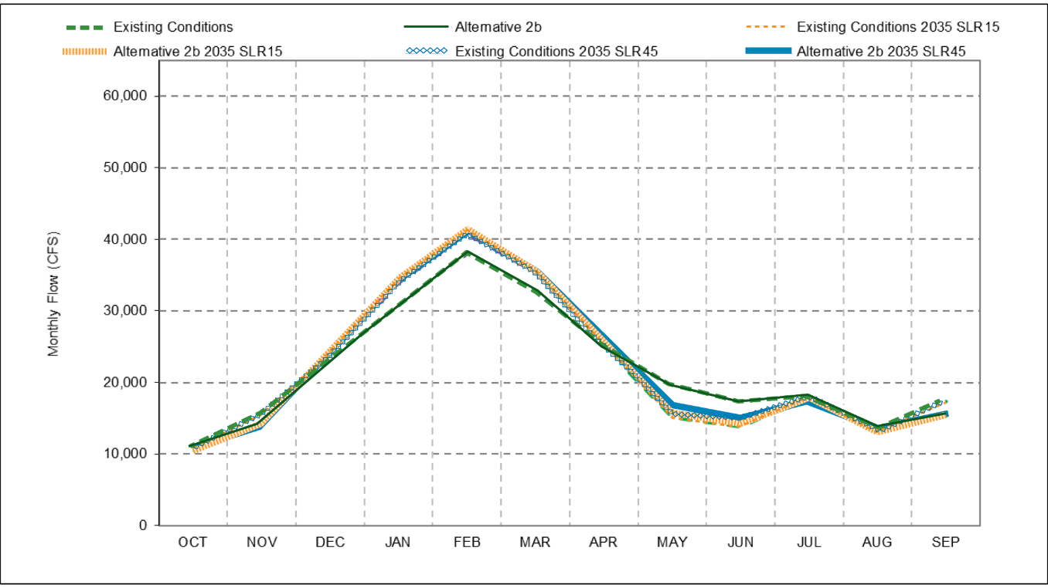

Figure 1 Sacramento River at Freeport Monthly Flow for the existing conditions and Refined Alternative 2b under current climate and near future climate centered around year 2035 with 15 cm and 45 cm of sea level rise

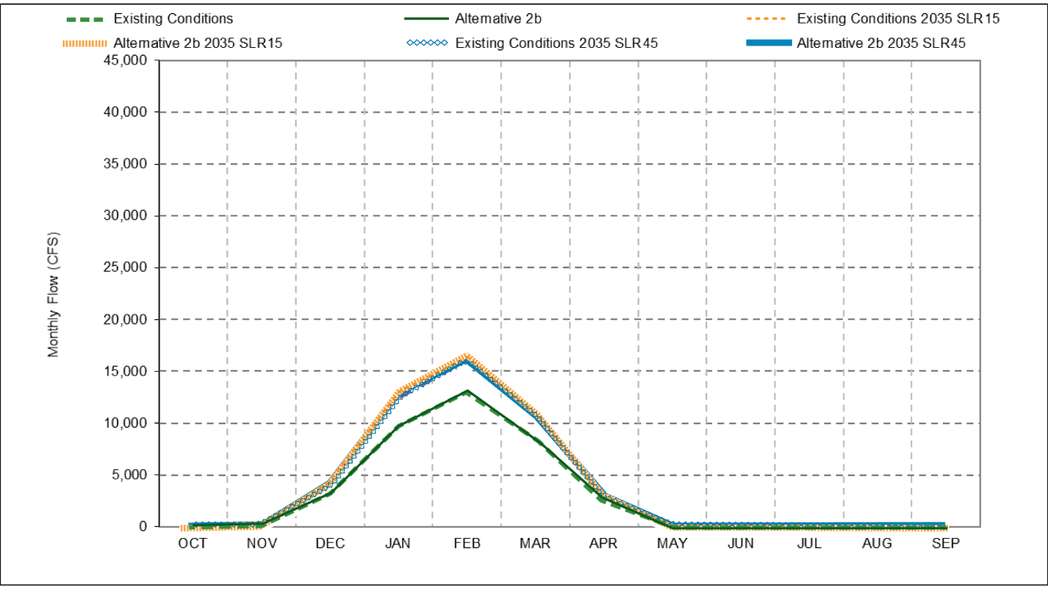

Figure 2 Monthly Yolo Bypass Flow for the existing conditions and Refined Alternative 2b under current climate and near future climate centered around year 2035 with 15 cm and 45 cm of sea level rise

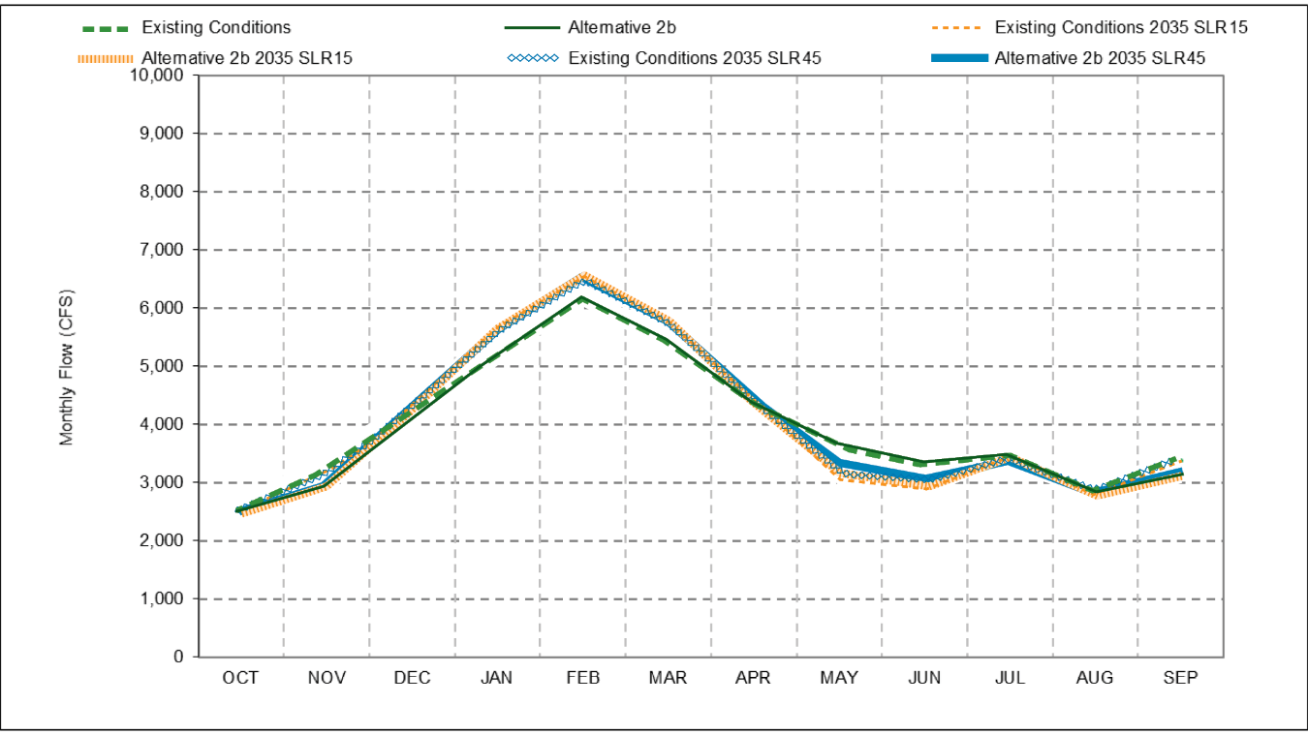

Figure 3 Monthly Georgiana Slough Flow for the existing conditions and Refined Alternative 2b under current climate and near future climate centered around year 2035 with 15 cm and 45 cm of sea level rise

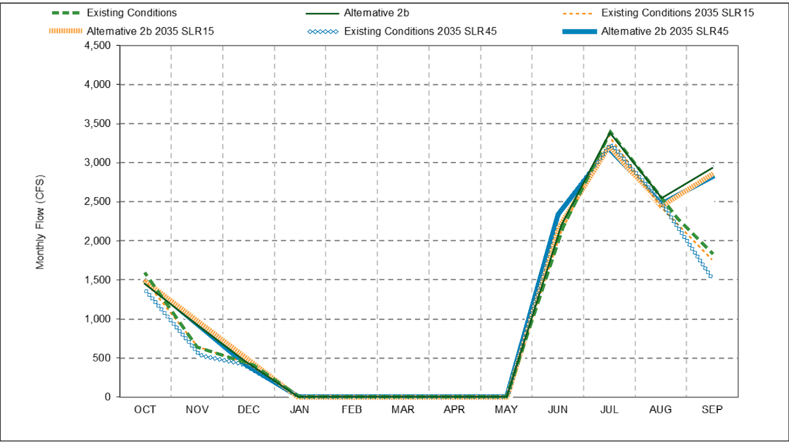

Figure 4 Monthly DCC Flow for the existing conditions and Refined Alternative 2b under current climate and near future climate centered around year 2035 with 15 cm and 45 cm of sea level rise

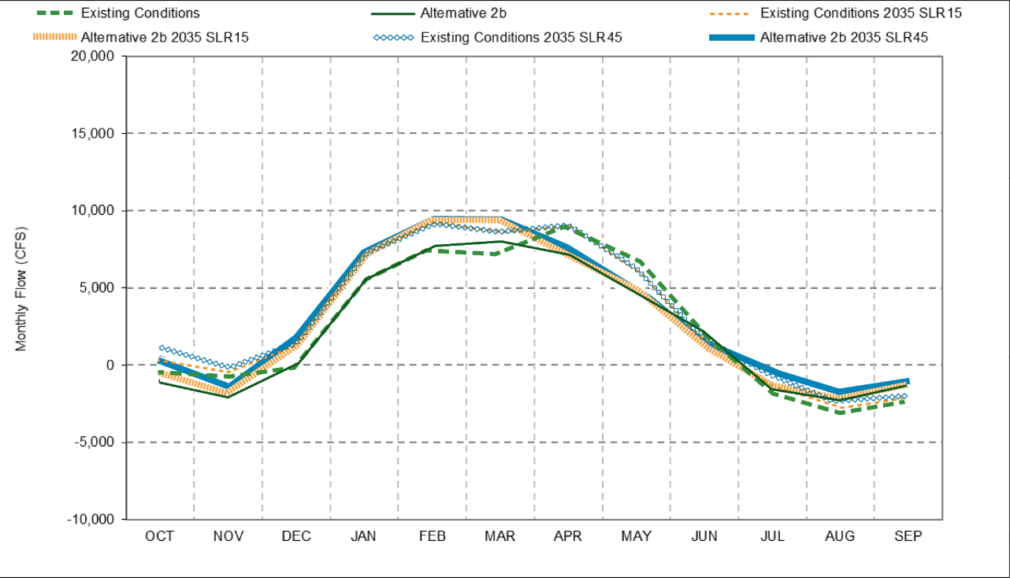

Figure 5 Monthly Qwest Flow for the existing conditions and Refined Alternative 2b under current climate and near future climate centered around year 2035 with 15 cm and 45 cm of sea level rise

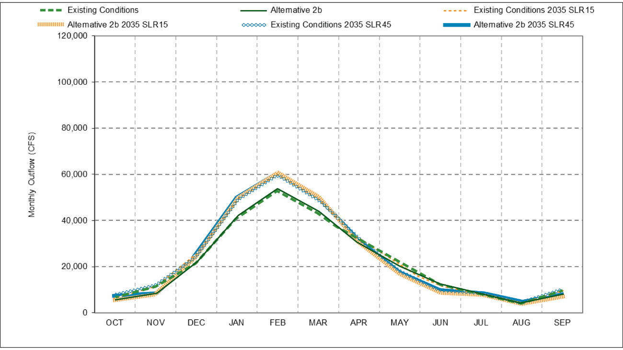

Figure 6 Monthly Delta Outflow for the existing conditions and Refined Alternative 2b under current climate and near future climate centered around year 2035 with 15 cm and 45 cm of sea level rise

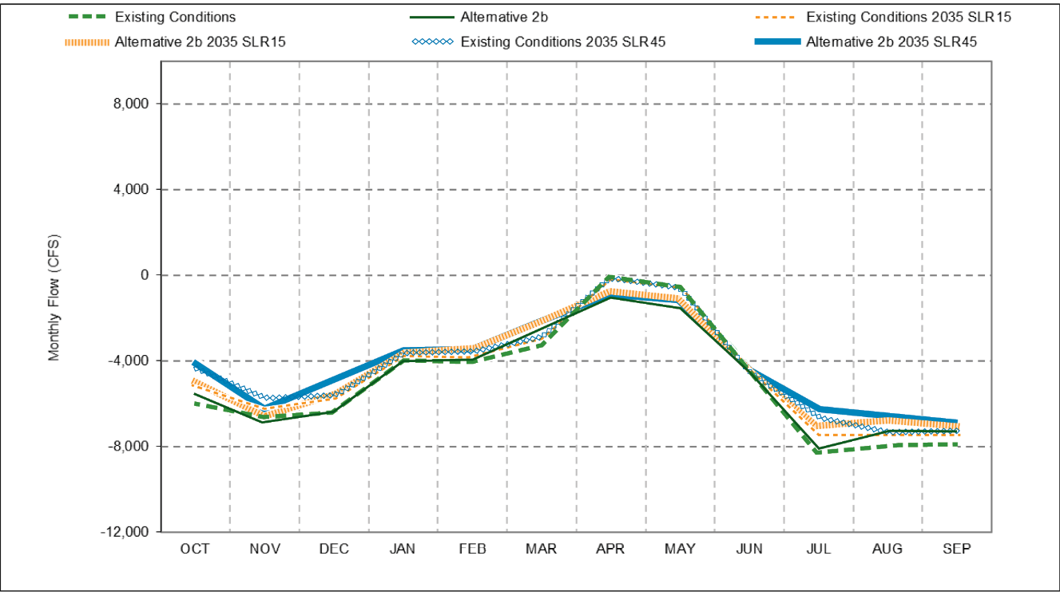

Figure 7 Combined Old and Middle River Monthly Flow for the existing conditions and Refined Alternative 2b under current climate and near future climate centered around year 2035 with 15 cm and 45 cm of sea level rise

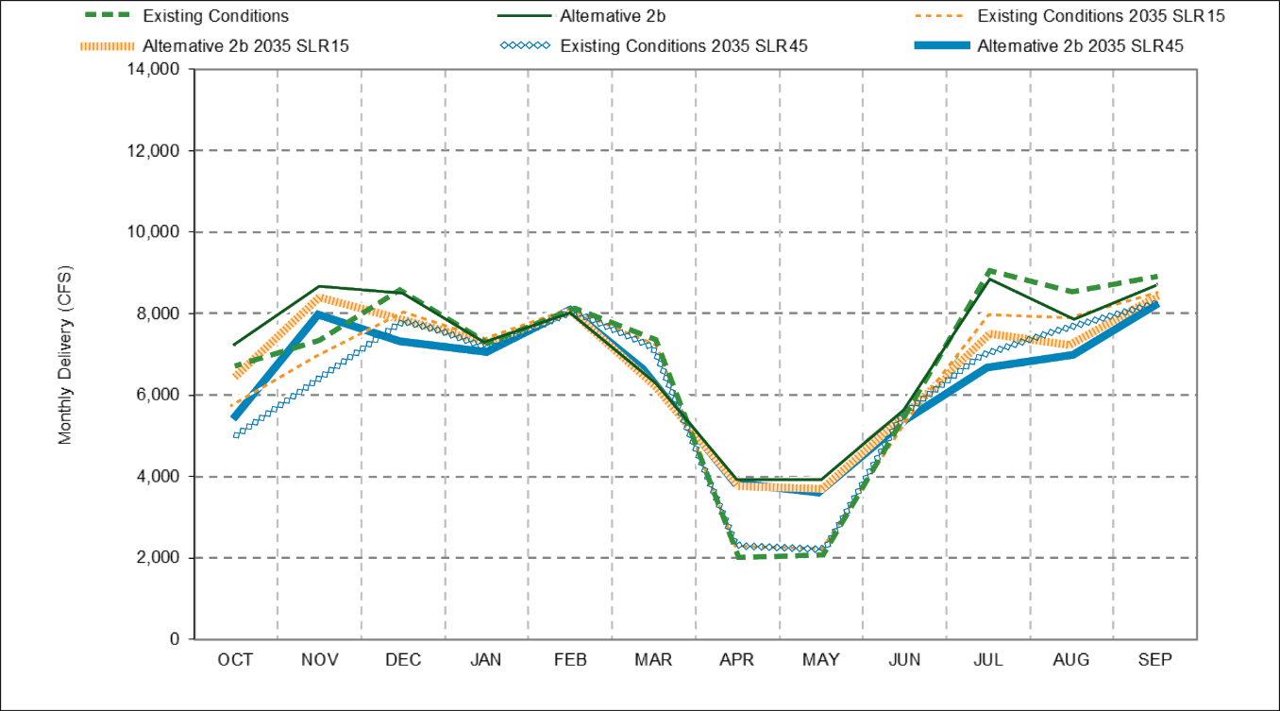

Figure 8 Monthly Delta Exports for the existing conditions and Refined Alternative 2b under current climate and near future climate centered around year 2035 with 15 cm and 45 cm of sea level rise

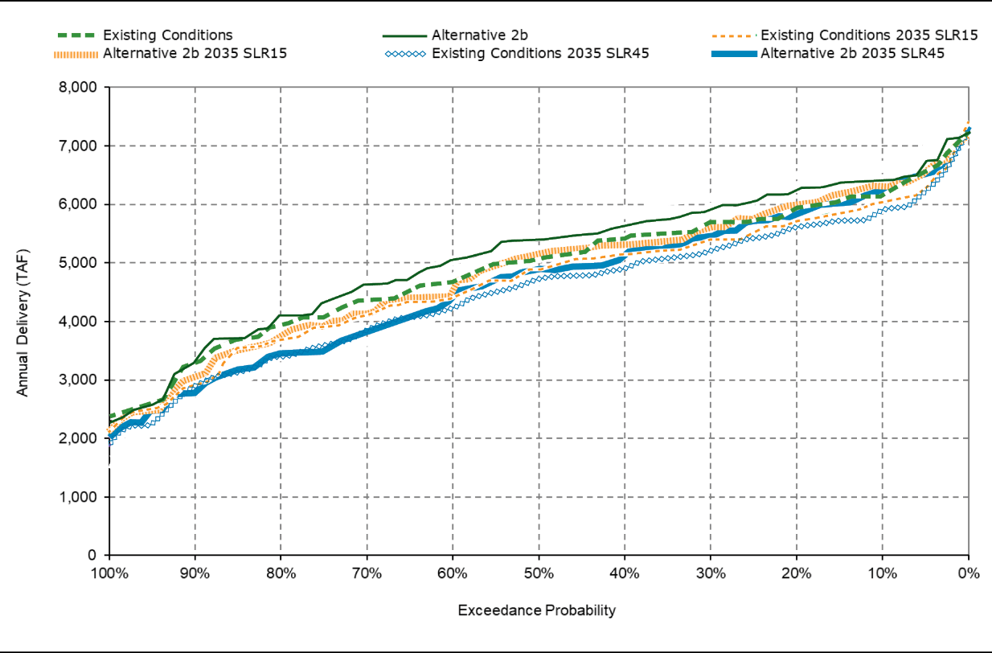

Figure 9 Annual Delta Exports for the existing conditions and Refined Alternative 2b under current climate and near future climate centered around year 2035 with 15 cm and 45 cm of sea level rise

This page intentionally left blank